Software Requirements Specification
Version Version # 1.0
Buyer’s Bid
Client: Maaraz Trading Company

Team Team # 3
Member Name | Member Roll # | Primary Responsibility
Bilal Ashfaq | L16-4120 | Appendix A, F, G, H, I & Editing & Compilation
Yasir Abbas | L16-4154 | Functional Requirements
Safi Ur Rehman | L16-4365 | Overall Description
Umer Shafique | L14-5850 | Introduction
Arslan Younas | L16-4306 | IV & V Report
Farrukh Tariq | L16-4095 | Non- Functional & Other Requirements

Table of Contents Error: Reference source not found
Revision History 3
1. Introduction 1
1.1 Product 1
1.2 Scope 1
1.3 Business Goals 1
1.4 Document Conventions 2
1.5 References 2
2. Overall Description 3
2.1 Product Features 3
2.2 User Classes and Characteristics 3
2.3 Operating Environment 3
2.4 Design and Implementation Constraints 4
2.5 Assumptions and Dependencies 4
3. Functional Requirements 5
3.1 Login User 5
3.2 Sign Up User 6
3.3 Create a Post describing buyers need 7
3.4 Edit post 8
3.5 Bid on a post 9
3.6 Block user 10
3.7 Update bid 11
3.8 Delete post 12
3.9 Delete bid 13
3.10 Send message 14
3.11 Create profile 15
3.12 Edit profile 16
3.13 Report spam 17
3.14 Add review 18
3.15 Delete Entire Conversation 19
3.16 Delete Specific Messages 20
3.17 Unblock user 21
3.18 Search Posts: 22
3.19 Remove User: 23
4. Nonfunctional Requirements 24
4.1 Performance Requirements 24
4.2 Security Requirements 24
5. Other Requirements 24
5.1 Usability 24
5.2 Reliability 24
5.3 Extensibility 25
5.4 Error handling 25
5.5 Compatibility 25
5.6 Responsiveness 25
Appendix A: Glossary 26
Appendix B: Analysis Models 27
Appendix C: Design Models 28
Appendix D: Screenshots 29
Appendix E: Test Cases 30
Appendix F: IV & V Report 31
Appendix G: Risk Report 32
Appendix H: Activity Timesheet 33
Appendix I: Updated project plan 34-36

Revision History
Name(s) | Date | Reason(s) For Change(s) | Version
Yasir Abbas | 19-9-2019 | Added a use case to support user profiling | 0.1
Yasir Abbas | 20-9-2019 | Changed overall description because it was not satisfactory. Features were not defined. | 0.2
Saif Ur Rehman | 20-9-2019 | Added new features in overall description. | 0.3
Arslan Younas | 20-9-2019 | Added support for common person to act as a seller also. | 0.4
Farrukh Tariq | 21-9-2019 | The other requirements were added. | 0.5
Bilal Ashfaq | 24-9-2019 | Added a limitation of tech illiterate users. | 0.6
Bilal Ashfaq | 25-9-2019 | Search use case is added. | 0.7
Umer Shafique | 25-9-2019 | Use case purpose were not in phrases. | 0.8
Farrukh tariq | 25-9-2019 | The meeting time was not added in project plan | 0.9
Yasir Abbas | 25-9-2019 | Use case assign rank to the bidder is removed because it is only an action by system in response to user action. | 1.0

Introduction

Product
The product we intend to build is a web-based bidding platform called Buyer’s Bid. Our product is unique because unlike other bidding platforms it favors buyers more than sellers. More specifically, our application will have two portals namely Seller portal and Buyer portal. Buyers will post the product they want with all the requirements. The post will be visible to registered sellers on their platform. Interested sellers will bid on the post and the amount offered by one seller will be hidden from the others. Then a bid rank will be assigned to each seller’s bid such that the seller with lowest offered amount will get the highest bid rank. Bid rank of every seller will be visible to others which will make them lower their price to get the highest bid rank. This way, sellers will ultimately reach the lowest amount they can take, which is a huge benefit for the buyer. Once the bidding time is over, buyer can select any seller he/she wants.

Scope
The major aim of Buyer’s Bid is to link producers, sellers and buyers in one place, thereby filling the gap that currently exists in online bidding. This application acts as an open forum where buyers and sellers can come together and exchange their products. The site makes sure that the sellers get a fair deal and buyers get a genuine product. Although, the application does provide a mechanism to verify the credibility of seller or buyer, it does not deal with the actual delivery of the product. So, the medium users choose to exchange products is out of the scope of this application.

Even though our application can be used by any class of user, but the main benefiters of this application will be small businesses. Since the large-scale businesses have their own specific network of suppliers and a huge customer base, they may not be the primary benefiters of this app. On the other hand, Startups and small-scale businesses like Maraaz Trading Company find it very hard to get stock form different suppliers. First of all, they mostly don’t find a supplier in time, even if they do, they don’t get a reasonable deal for their stock. However, if they can get what they need by just posting on a website, it would be very beneficial for them.

Furthermore, most of the people are reluctant to use online shopping sites because they fear that they will be overcharged. Since, Buyer's Bid is literally all about a buyer’s bid, it will be very valuable for online shoppers.

Business Goals
The major goals that our client will achieve by using Buyer’s Bid are as follows:

- The client will not have to roam around in search of a supplier for its stock anymore. All that is needed of client now is to post the required stock on Buyer’s Bid and get a reasonable bid for the stock.
- Since Maraaz Trading Company is just known to locals currently, Buyer’s Bid will be a huge opportunity for our client to expand its customer base.
- The application will help increase the credibility of our client among its customers through our rating system. Customers will be able to view the rating profile of our client before buying something.
- Furthermore, Maraaz Trading Company will be able to keep track of fraud suppliers and customers. This is possible by viewing their profile and analyzing the experience of other buyers or sellers before making a deal.

Document Conventions
Here are the conventions followed while making this document:
- Name of the client (Maraaz Trading Company) is used with bold text throughout the
document.
- Name of application (Buyer’s Bid) is used with bold text throughout the document.
- Name of technologies and software’s like AngularJS, MySQL have been italicized
throughout the document.
- Figures like time and percentage have also been italicized throughout the document.

References
[1] cometchat, [Online]. Available: https://www.cometchat.com/chat-api

Overall Description

Product Features
The major features provided by our application will be:
  - Make a Post
Whenever a user feels he is in need of something, he can simply make a post describing his needs which will be visible to other registered users.
  - Make a Bid
When a seller comes across a buyer that he thinks could be a potential customer, he can simply make a bid on his post.
  - Assign a Bid Rank
Our system will assign highest rank to the person with the lowest bid. Lower the bid higher the rank.
  - Chatting mechanism
Our application will have a chatting mechanism to allow two-way conversation between buyer and seller.
- Rating & Review mechanism
The application provides users with a mechanism to rate other users and make reviews about a seller or buyer depending upon their experience with that person.
- Searching mechanism
Application provides a mechanism to sellers for searching posts by product names and buyer names.
- Featured Users
The application will display featured buyers on the home page of sellers and vice versa. Featured users are simply the ones with high ratings.

User Classes and Characteristics
The major users of this product will be whole sellers, shop keepers, general public, producers and platform manager. In fact, any person who knows how to use internet can use our platform.
- Whole sellers are the businessmen who sell their products in bulk. They can use our platform to sell their products.
- Shop keepers can also buy products on minimum rates.
- General Public are the common people who surf online shopping sites to buy different products. They will be the main users of our system.
- Manufactures can be corporate organizations or small-scale businesses which manufacture something. They can also sell their products directly by using our platform to get rid of retail stores and distribution channels.
- Platform manager is the administrator of our system. He can review the scam reports submitted by buyers and sellers. Moreover, he can block accounts temporarily or permanently.

Operating Environment
Being a web-based application, Buyer's Bid does not have any specific operating system requirements. It can operate on any operating system including LINUX, WINDOWS, ANDROID and iOS as long as the system has a web browser that supports AngularJS, HTML5 and Bootstrap. Similarly, the application does not have any hardware constraints either. Moreover, it will be a standalone application and would not need another software to operate.

Design and Implementation Constraints
Limited web development knowledge of most of our team members is causing the major implementation constraint on our application. We are bound to use AngularJS as the frontend framework along with MySql for backend. The reason is that these are the only technologies that most of our team members are familiar with. We cannot use other modern and fast frameworks like React and DBMS technologies like MongoDB.

Furthermore, a class of our potential users (sellers) are not computer literate. This further put design constraints because we would have to make interface extremely user friendly.

Assumptions and Dependencies
The chatting feature of our application is very crucial but the problem is that our team doesn’t have expertise in network programming. So, it will be very difficult for us to write chatting code from scratch. So far we have planned to use pre-built API for chatting and have assumed that chatting API provided by [1] will be easily integrated to our application and will not cost us any money. So, if the chatting API is integrated easily to our application, it will help us save tons of money and time which could be wasted trying to figure out the network programming. But in most of the cases online APIs are not compatible with all languages. Moreover, they are not even free of cost. If this turns out to be the case, things will get very difficult for us.

Functional Requirements

Login User
Identifier |  | UC-1
Purpose |  | Allow user to login the system
Priority |  | High
Actors |  | Common Public, Wholesaler, Shopkeeper, Manufacturer
Pre-conditions |  | The user must have an account already.
Post-conditions |  | The user has access to full functionality of system.
Typical Course of Action
S# | Actor Action |  | System Response
1 | The user enters URL. |  | System shows the main page of website.
2 | The user enters the login tab by clicking on login button. |  | The system shows the login form.
3 | The user enters login and password information and clicks on login button. |  | The system authenticates the user name and password and user can now access the system functionality.
Alternate Course of Action
S# | Actor Action |  | System Response
1 | The user enters login and password information and clicks on login button |  | The system shows error that the login and password doesn’t exist/empty fields.
2
3
…
Table 1: UC-1

Sign Up User
Identifier |  | UC-2
Purpose |  | Allow user to sign up as new user
Priority |  | High
Actors |  | Common Public, Wholesaler, Shopkeeper, Manufacturer
Pre-conditions |  | There is no pre condition for the Sign-Up use case.
Post-conditions |  | The user can now login to the system to get full access to the system functionality.
Typical Course of Action
S# | Actor Action |  | System Response
1 | The user enters URL. |  | System shows the main page of website.
2 | The user enters the Sign-Up tab by clicking on signup button. |  | The system shows the login form.
3 | The user fills all signup requirements and clicks on sign up button. |  | The system authenticates the user and directs user to make profile page.
Alternate Course of Action
S# | Actor Action |  | System Response
1 | The user fills all signup requirements and clicks on sign up button. |  | The system shows error that the user already exists/password weak/fill all the fields.
2
3
…
Table 2: UC-2

Create a Post describing buyers need
Identifier |  | UC-3
Purpose |  | Let buyers make a Post describing their need
Priority |  | High
Actors |  | Common Public, Wholesaler, Shopkeeper, Manufacturer
Pre-conditions |  | The user must have an account to post his need.
Post-conditions |  | The user’s post will be available to sellers for bidding.
Typical Course of Action
S# | Actor Action |  | System Response
1 | The user enters the post tab by clicking post your need button. |  | The system directs the user to the form where he can fill relevant fields to make a post.
2 | The user enters his requirements and clicks on post button. |  | The system successfully uploads the post.
3 | The user reviews his post by clicking on review my post button. |  | The system shows user the post that he made.
Alternate Course of Action
S# | Actor Action |  | System Response
1 | The user enters his requirements and clicks on post button. |  | The system shows error that the requirements are not sufficient.
2
3
…
Table 3: UC-3

Edit post
Identifier |  | UC-4
Purpose |  | Allow users to edit post
Priority |  | High
Actors |  | Common Public, Wholesaler, Shopkeeper, Manufacturer
Pre-conditions |  | The user must have posted something about his need.
Post-conditions |  | User’s updated post will be available for sellers to bid.
Typical Course of Action
S# | Actor Action |  | System Response
1 | The user goes to my posts tab. |  | The system shows the posts the user made.
2 | The user clicks on the post that he wants to edit. |  | The system shows the post content.
3 | The user enters the editing tab by clicking on edit my post button. |  | The system shows the editing tab where user can edit his post.
4 | The user makes changes and clicks the “Make changes” button. |  | The system shows the edited post to the user.
Alternate Course of Action
S# | Actor Action |  | System Response
1
2
3
…
Table 4: UC-4

Bid on a post
Identifier |  | UC-5
Purpose |  | Bid on a post
Priority |  | High
Actors |  | Common Public, Wholesaler, Shopkeeper, Manufacturer
Pre-conditions |  | The user must have an account already.
Post-conditions |  | The user bid will be made available in bidding section of the buyer.
Typical Course of Action
S# | Actor Action |  | System Response
1 | The user clicks on the post he wants to bid. |  | The system displays the information about the post.
2 | The user clicks on button “Make a bid” to make a bid. |  | The system shows the form that needs to be filled to make bid.
3 | The user fills the form and presses “Make bid” button. |  | The system enters a new bid in the bid section of the buyer and assigns a rank to the seller’s bid.
Alternate Course of Action
S# | Actor Action |  | System Response
1 | The user fills the form and presses “Make bid” button. |  | The system shows error that the following field required.
2
3
…
Table 5: UC-5

Block user
Identifier |  | UC-6
Purpose |  | Block a user you don’t want to converse with
Priority |  | Medium
Actors |  | Common public, Wholesaler, Shopkeeper, Manufacturer
Pre-conditions |  | There user must be logged in the system.
Post-conditions |  | The blocked person cannot converse with the person who blocked him/her.
Typical Course of Action
S# | Actor Action |  | System Response
1 | The user clicks on the chat thread of the user he wants to block. |  | The system displays the chat thread between both users.
2 | The user clicks on button “Block” to block the user. |  | The system shows a dialogue box asking for confirmation.
3 | The user presses the “Yes” button to confirm. |  | The system will block messages from the blocked user.
Alternate Course of Action
S# | Actor Action |  | System Response
1 | The user presses the “No” showing he don’t want to block. |  | The system will not block messages from the user.
2
3
…
Table 6: UC-6

Update bid
Identifier |  | UC-7
Purpose |  | Update bid to get higher rank
Priority |  | High
Actors |  | Common Public, Wholesaler, Shopkeeper, Manufacturer
Pre-conditions |  | The user must have placed at least one bid.
Post-conditions |  | The user rank will be updated according to his new bid.
Typical Course of Action
S# | Actor Action |  | System Response
1 | The user goes to “My bids” menu by clicking on “My bids” button. |  | The system shows list of posts where the user has made bids.
2 | The user clicks on button “Update bid” to update his bid. |  | The system shows the form that needs to be filled to make changes to bid.
3 | The user fills the form and presses “Make changes”. |  | The system updates the bid and updated bid is now shown to buyer.
Alternate Course of Action
S# | Actor Action |  | System Response
1 | The user fills the form and press “Make changes”. |  | The system shows error that the following field required.
2
3
…
Table 7: UC-7

Delete post
Identifier |  | UC-8
Purpose |  | Delete post if need fulfilled
Priority |  | High
Actors |  | Common Public, Wholesaler, Shopkeeper, Manufacturer
Pre-conditions |  | The user must have made a post already.
Post-conditions |  | The user bid will be no more available in bidding section of the sellers/bidders.
Typical Course of Action
S# | Actor Action |  | System Response
1 | The user goes to my posts tab. |  | The system shows the posts user made.
2 | The user clicks on the post that he wants to Delete. |  | The system shows the post content.
3 | The user clicks on the button “Delete Post”. |  | The system deletes user’s post from posts menu. It will be no more visible to any user.
Alternate Course of Action
S# | Actor Action |  | System Response
1
2
3
…
Table 8: UC-8

Delete bid
Identifier |  | UC-9
Purpose |  | Delete bid if not suitable
Priority |  | High
Actors |  | Common Public, Wholesaler, Shopkeeper, Manufacturer
Pre-conditions |  | The user must have placed at least one bid.
Post-conditions |  | The user bid will no more be available to buyer.
Typical Course of Action
S# | Actor Action |  | System Response
1 | The user goes to “My bids” menu by clicking on “My bids” button. |  | The system shows list of post where the user has already made a bid.
2 | The user clicks on button “Delete bid” to delete his bid. |  | The system asks for the confirmation message.
3 | The user confirms the deletion process by clicking “Yes”. |  | The system deletes the bid and bid is no more available in buyers post.
Alternate Course of Action
S# | Actor Action |  | System Response
1 | The user clicks “No”. |  | The system will not delete the bid.
2
3
…
Table 9: UC-9

Send message
Identifier |  | UC-10
Purpose |  | Allows user to send message to a registered user
Priority |  | High
Actors |  | Common Public, Wholesaler, Shopkeeper, Manufacturer
Pre-conditions |  | User must have logged in the system.
Post-conditions |  | User’s message is now displayed to the recipient.
Typical Course of Action
S# | Actor Action |  | System Response
1 | The user goes to profile of the user he wants to message. |  | The system shows the profile of the user.
2 | The user clicks on button “Send Message” to send a message. |  | The system directs user to chat menu.
3 | The user types message and clicks send. |  | The system adds a new message in thread.
Alternate Course of Action
S# | Actor Action |  | System Response
1 | The user types message and clicks send. |  | The system shows error that you cannot send message to this user. (blocked)
2
3
…
Table 10: UC-10

Create profile
Identifier |  | UC-11
Purpose |  | Allows user to create his/her profile
Priority |  | High
Actors |  | Common Public, Wholesaler, Shopkeeper, Manufacturer
Pre-conditions |  | The user must be logging in the system for the first time. (Sign Up)
Post-conditions |  | User’s profile will be saved in the system.
Typical Course of Action
S# | Actor Action |  | System Response
1 | User logs in for the first time (Signs Up) |  | System redirects user to “Create Your Profile” page.
2 | The user fills the details and presses save. |  | The system asks for the confirmation to save.
3 | The user says Yes by clicking on “Save Changes” Button. |  | The system makes a profile of the user by saving his record.
Alternate Course of Action
S# | Actor Action |  | System Response
1
2
3
…
Table 11: UC-11

Edit profile
Identifier |  | UC-12
Purpose |  | Allow user to edit his/her profile
Priority |  | High
Actors |  | Common Public, Wholesaler, Shopkeeper, Manufacturer
Pre-conditions |  | The user must have logged in the system.
Post-conditions |  | No post condition
Typical Course of Action
S# | Actor Action |  | System Response
1 | The user goes to settings menu by clicking settings button. |  | The system shows the settings menu.
2 | The user clicks “Edit profile”. |  | The system shows the profile page with the editable fields.
3 | The user makes changes and clicks on “Save Changes” button. |  | The system updates the user’s record.
Alternate Course of Action
S# | Actor Action |  | System Response
1
2
3
…
Table 12: UC-12

Report spam
Identifier |  | UC-13
Purpose |  | Allows user to report spam activity
Priority |  | Medium
Actors |  | Common Public, Wholesaler, Shopkeeper, Manufacturer
Pre-conditions |  | The user must be logged in the system.
Post-conditions |  | Admin will be notified to review the spam activity.
Typical Course of Action
S# | Actor Action |  | System Response
1 | The user clicks on the profile of the seller/buyer he wants to report spam. |  | The system shows the profile of the seller/buyer.
2 | The user clicks “Report spam” button. |  | The system shows the form that needs to be filled to report someone spam.
3 | The user fills the form and clicks “Report” button. |  | The system will notify spam activity to the admin for review.
Alternate Course of Action
S# | Actor Action |  | System Response
1 | The user clicks on the profile of the seller/buyer he wants to report spam. |  | The system shows the profile of the seller/buyer.
2 | The user clicks “Report spam” button. |  | The system shows the form that needs to be filled to report someone spam.
3 | The user clicks “Don’t Report” button. |  | The system will take user back to the profile of user he was reporting as spam.
…
Table 13: UC-13

Add review
Identifier |  | UC-14
Purpose |  | Add review to facilitate sellers in making reputation
Priority |  | High
Actors |  | Common Public, Wholesaler, Shopkeeper, Manufacturer
Pre-conditions |  | The user must have logged in the system.
Post-conditions |  | The review will be now visible to all users.
Typical Course of Action
S# | Actor Action |  | System Response
1 | The user goes to profile of the seller he wants to review. |  | The system shows the profile page of the seller.
2 | The user navigates to the review section and click on “Add Review” button. |  | System displays review form.
3 | User writes a review and clicks “Add” button. |  | The system adds a new review to the user’s profile.
Alternate Course of Action
S# | Actor Action |  | System Response
1 | The user goes to profile of the seller he wants to review. |  | The system shows the profile page of the seller.
2 | The user navigates to the review section and click on “Add Review” button. |  | System displays review form.
3 | User clicks “Close” button. |  | The system takes user back to the profile of user he/she was reviewing.
…
Table 14: UC-14

Delete Entire Conversation
Identifier |  | UC-15
Purpose |  | Delete message
Priority |  | High
Actors |  | Common Public, Wholesaler, Shopkeeper, Manufacturer
Pre-conditions |  | The user must have made message to someone.
Post-conditions |  | The conversation thread will be no more available to read.
Typical Course of Action
S# | Actor Action |  | System Response
1 | The user clicks on “My chats” menu. |  | The system shows the chat menu containing all the threads.
2 | The user clicks on the delete button corresponding to the thread he wants to delete. |  | The system asks for the confirmation to delete.
3 | The user clicks “Yes” to confirm the deletion. |  | The system removes the chat record from the system.
Alternate Course of Action
S# | Actor Action |  | System Response
1 | The user clicks “No”. |  | The system will not remove the chat.
2
3
…
Table 15: UC-15

Delete Specific Messages
Identifier |  | UC-16
Purpose |  | Delete message
Priority |  | High
Actors |  | Common Public, Wholesaler, Shopkeeper, Manufacturer
Pre-conditions |  | The user must have made messages to someone.
Post-conditions |  | The deleted messages will be no more available to read.
Typical Course of Action
S# | Actor Action |  | System Response
1 | The user clicks on “My chats” menu. |  | The system shows the chat menu containing all the threads.
2 | The user clicks on a particular thread in which he/she wants to delete messages. |  | The system asks for the confirmation to delete.
3 | The user clicks “Yes” to confirm the deletion. |  | The system removes deleted messages from the thread.
Alternate Course of Action
S# | Actor Action |  | System Response
1 | The user clicks “No”. |  | The system will not remove the messages.
2
3
…
Table 16: UC-16

Unblock user
Identifier |  | UC-17
Purpose |  | Unblock user
Priority |  | High
Actors |  | Common Public, Wholesaler, Shopkeeper, Manufacturer
Pre-conditions |  | The user must have blocked some user already.
Post-conditions |  | There is no post condition.
Typical Course of Action
S# | Actor Action |  | System Response
1 | The user clicks on the chat thread of the user he/she wants to unblock. |  | The system displays the chat thread between both users.
2 | The user clicks on button “Unblock” to unblock the user. |  | The system shows a dialogue box asking for confirmation.
3 | The user presses the “Yes” button to confirm. |  | The system will allow both users to chat again.
Alternate Course of Action
S# | Actor Action |  | System Response
1 | The user presses the “No” showing he/she doesn’t want to unblock. |  | The system will not unblock the blocked user.
2
3
…
Table 17: UC-17

Search Posts:
Identifier |  | UC-18
Purpose |  | Allows users to search different posts open for bid
Priority |  | High
Actors |  | Common Public, Wholesaler, Shopkeeper, Manufacturer
Pre-conditions |  | The user must be logged into his/her account
Post-conditions |  | Search will be stored in user’s search history.
Typical Course of Action
S# | Actor Action |  | System Response
1 | The user clicks on the search bar at the home page. |  | The system highlights the search bar indicating that user can start writing.
2 | The user writes the name of product he/she wishes to search. |  | The name is displayed in search bar.
3 | The user presses the “Search” button. |  | The system shows the search results.
Alternate Course of Action
S# | Actor Action |  | System Response
1 | The user presses the “Search” button. |  | System displays error message “No internet connection”.
2
3
…

Table 18: UC-18

Remove User:
Identifier |  | UC-19
Purpose |  | Allows admin to remove a particular user account.
Priority |  | Low
Actors |  | Administrator
Pre-conditions |  | Administrator receives scam request about user.
Post-conditions |  | User’s account is removed from the system.
Typical Course of Action
S# | Actor Action |  | System Response
1 | The user clicks on “Scam Reports” tab. |  | The system displays all the scam reports received.
2 | User opens a specific “Scam Report”. |  | Full report information is displayed.
3 | The user presses “Remove Scammer” button. |  | The system asks for confirmation.
 | The user presses “Yes” button. |  | The system removes the scammer.
Alternate Course of Action
S# | Actor Action |  | System Response
1 | The user presses the “Reject Report” button. |  | System marks the scam report as rejected.
2
3
…

Table 19: UC-19

Nonfunctional Requirements

Performance Requirements
Performance is one of the main concerns of our system. Here are a few performance requirements set by our team and client for our application:
- The application shall allow novice (new) buyers to write a post in less than 7 minutes.
- The application shall allow regular buyers to write a post in less than 4 minutes.
- The application shall be able to process a post in less than 1 seconds.
- The application shall allow a novice seller to make a bid in less than 2 minutes.
- The application shall allow a regular seller to make a bid in less than 1 minute.
- The application shall be able to process a bid in less than 1 seconds.
- The application shall fetch and display 90 percent of search results in less than 1 second.
- The application shall allow a user to write a review in less than 4 minutes.
- The application shall be able to process a review in less than 1 seconds.

Security Requirements
Security is another major concern of our system. Here are a few security requirements set by our team and client for our application:
- Application shall restrict functionalities access based on the user’s identity. Functionalities
available to administrator shall be different than those available to buyers or sellers.
- Application shall not allow a seller to view the bid information of another seller. The bid
information shall only be visible to the bidder himself or the buyer who posted the
requirements.
  - Application shall not allow any user to reveal their true identity.
- Application shall not allow any user to add their contact information in their profile.
- Application’s chatting mechanism shall be the only way buyers and sellers communicate.

Other Requirements

Usability
The interface of this application shall support ease of use and ease of learning. User shall be able to use the application without any formal training.

Reliability
Data and information on our system is very critical, therefore, system shall be accessible at all times.

Extensibility
For each task there shall be a separate module and each module shall be able to work independently. Extension of each module shall not be a problem.

Error handling
Error handling shall be done on multiple levels to ensure system stability.

Compatibility
It is web-based system and shall be compatible with all the browsers and platforms.

Responsiveness
The interface of website shall be responsive to all devices and all screen sizes.
Appendix A: Glossary
IV&V: Independent Verification and Validation HTML: Hypertext Markup Language
AngularJS: a JavaScript-based open-source front-end web framework UC: User Case
React: React is a JavaScript library for building user interfaces
HTML5: HTML5 is a software solution stack that defines the properties and behaviors of web page
Windows, Linux, iOS & Android: Operating Systems API: Application Programming Interface
MySQL: an open-source relational database management system Actor: User of a system
MongoDB: MongoDB is a cross-platform document-oriented database program classified as a NoSQL database program.
Bid: Amount offered by a seller. DBMS: Database Management System
Bid Rank: a number assigned to a seller’s bid denoting how good that bid is.
Bootstrap: Bootstrap is a free and open-source CSS framework directed at responsive, mobile-first front-end web development.

Appendix B: Analysis Models
<Include the following analysis models: use-case diagram, entity-relationship diagram, class diagram, data flow diagram.>
Appendix C: Design Models
< Include the following design model: component diagram.>
Appendix D: Screenshots
< Include all screenshots of your software application’s graphical user interface.>
Appendix E: Test Cases
< Fill out the following template for each test case.>

Identifier | TC-1
Priority | <Choose one from {High, Medium, Low}>
Related requirements(s) | <Include use-case identifier(s) for functional requirement(s) and SRS section/sub-section number(s) for other requirement(s).>
Short description | …
Pre-condition(s) | …
Input data | …
Detailed steps | …
Expected result(s) | …
Post-condition(s) | …
Table 2: TC-1

Appendix F: IV & V Report
IV & V Resource

Name Roll # Signature

S# | Defect Description | Origin Stage | Status | Fix Time
 |  |  |  | Hours | Minutes
1 | No user profiling supported | No user profiling | changed | 00 | 30
2 | User base is recognized as novice | Not recognized | changed | 00 | 30
3
…
Table 3: List of non-trivial defects

Appendix G: Risk Report

Project Risks

Risk Description | Impact  (1 – 10) | Probability  (0 – 1) | Risk  Exposure | Weeks Active | Mitigation Strategy
A team member (Arslan Younas) is extremely Sick. This might lead to delay in this phase because of less work force. | 7 | 0.9 | 6.3 | 3 | Make Arslan Younas IV & V for this phase.
Umer Shafique is doing a full-time job so he may not be easily available. | 5 | 1 | 5 | Full  Duration of Project | Make Umer Shafique IV & V for implementation phase because implementation requires high commitment of time.
Client Representative may not appear on first presentation. | 9 | 0.3 | 2.7 | 2 | Convince the client to show up and if necessary, tell him that he will not receive the product if he doesn’t.

Appendix H: Activity Timesheet

Activity | Time
Activity | Hours | Minutes
Requirements Engineering | 29 | 20
Analysis and Design
Implementation
Testing
Deployment
Project Management | 12 | 30
IV & V | 5 | 0

Project Manager

Name Roll # Signature

Appendix I: Updated Project Plan
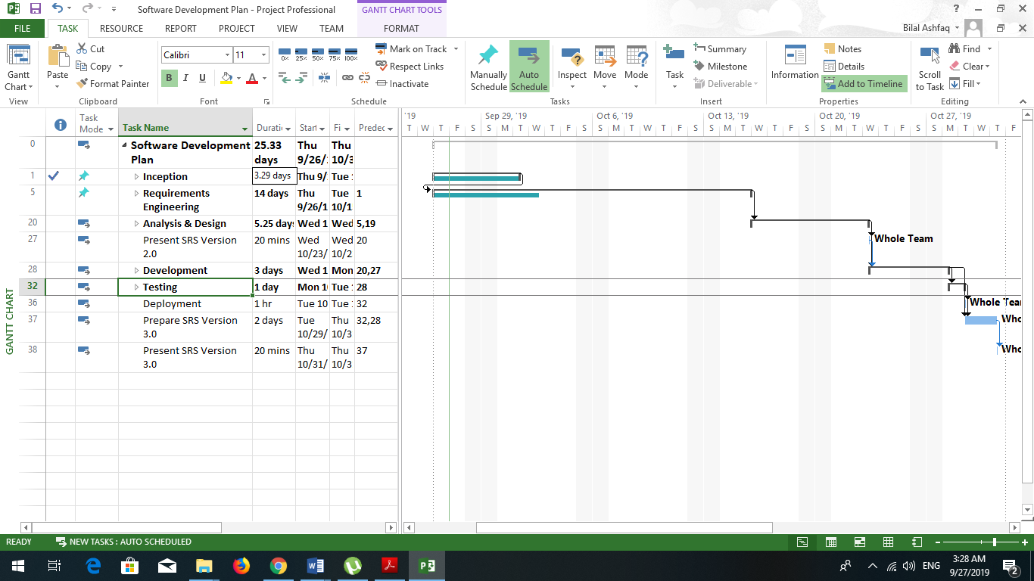

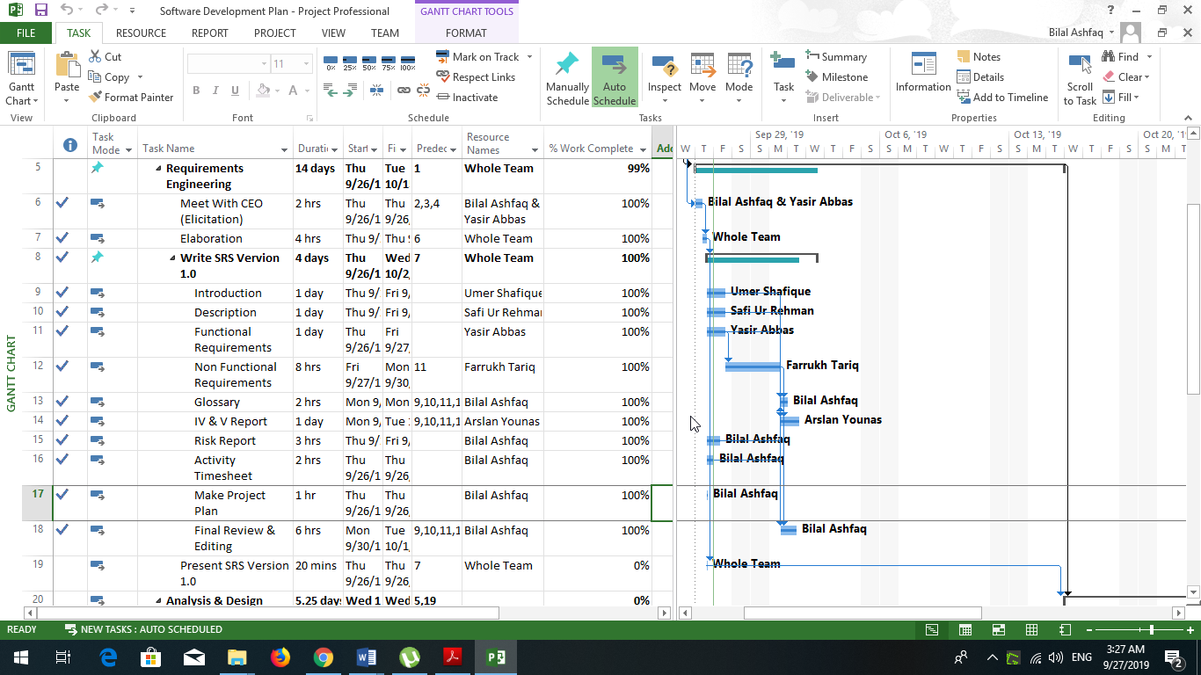

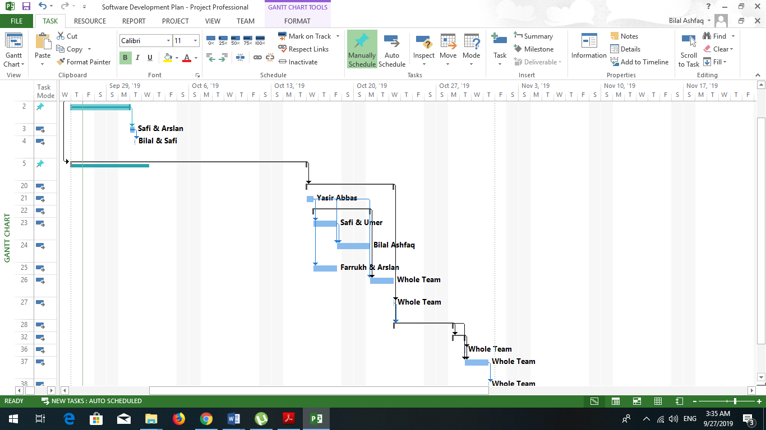

Risks should be sorted in descending order of risk exposure.
Risk Exposure = Risk Impact x Risk Probability

